LANGSMITH
Setup Guide

Step-by-Step Instructions to Configure LangSmith for Your Application
What is LangSmith?
LangSmith is a developer platform built by LangChain that helps you debug, test, evaluate, and monitor LLM (Large Language Model) applications. Whether you are building chatbots, AI agents, or RAG (Retrieval-Augmented Generation) pipelines, LangSmith gives you full visibility into every step of your LLM application's execution.

Why is LangSmith Required?
When building applications powered by large language models, things can go wrong in ways that are hard to diagnose. LangSmith solves this by providing:

🔍 Tracing and Debugging  See every LLM call with exact prompts, responses, and latency. Find and fix issues quickly. | 📊 Evaluation  Create datasets and run evaluations to measure how well your application performs over time.
📡 Monitoring  Monitor performance in real time - track costs, latency, and error rates once your app is live. | 🤝 Collaboration  Share traces, annotate outputs, and review results together for high-quality AI applications.

In short, LangSmith is essential for anyone who wants to build reliable, production-ready LLM applications - not just prototypes.

Steps to Generate a LangSmith API Key
To connect your application with LangSmith, you need an API key. Follow the steps below to generate one.
STEP 1 Open LangSmith Signup Page
Goal: Reach the LangSmith account creation screen to sign up and choose your data region.
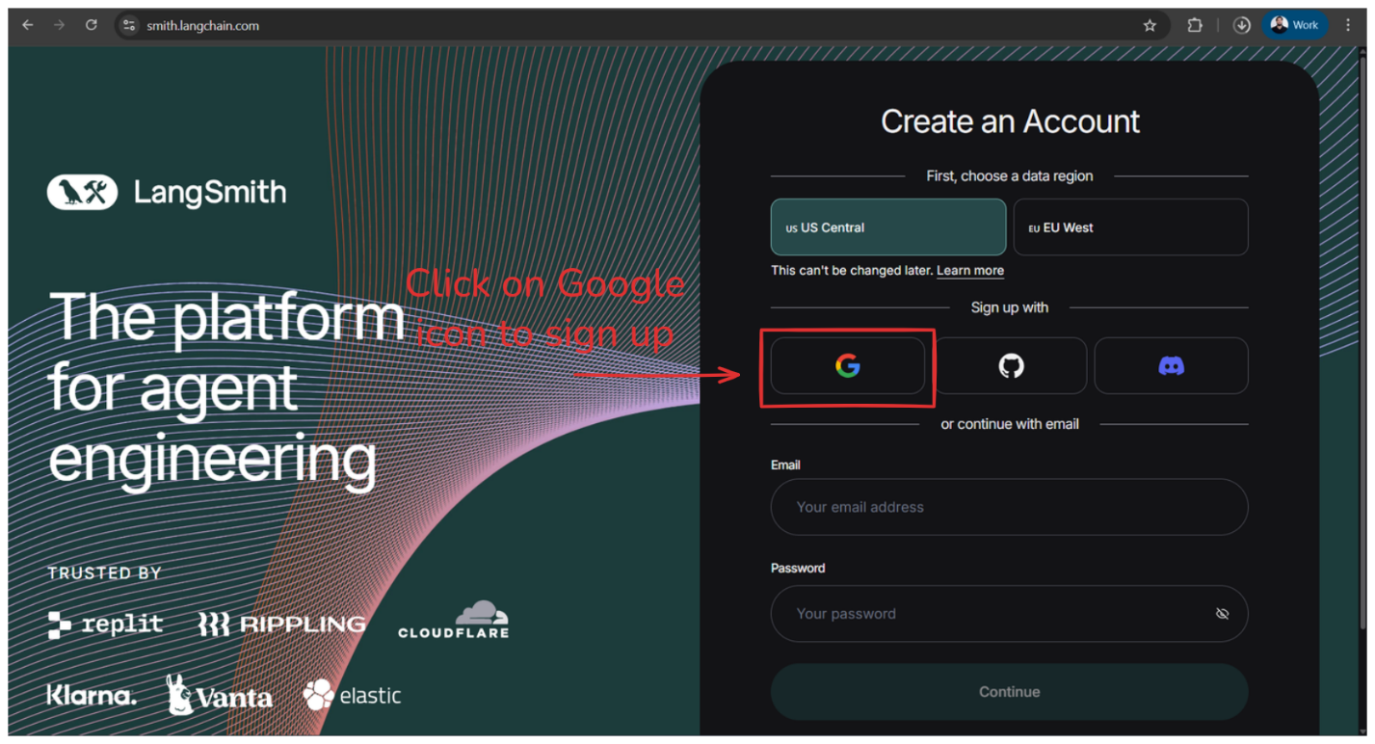
Figure 1.1 - LangSmith Sign-Up Page

1.1 Open a Web Browser
Use any modern browser such as Google Chrome, Microsoft Edge, Firefox, or Safari.
Recommended: Chrome for the smoothest experience (especially if you plan to use developer tools later).
1.2 Go to the LangSmith Website
- Click on the address bar at the top of your browser.
- Type (copy-paste or open) this URL exactly:
https://smith.langchain.com
- Press Enter.
1.3 Confirm You're on the Correct Page
You should see:
- The LangSmith branding on the left ("The platform for agent engineering").
- A Create an Account panel on the right.
- A section called "First, choose a data region" (e.g., US Central / EU West).
- Sign-up options (Google / GitHub / Discord) and/or email signup fields.
1.4 Quick Troubleshooting (If the Page Doesn't Load)
⚠️ Troubleshooting Tips
Blank/failed load: Refresh once (Ctrl+R / Cmd+R).
Still not opening: Try opening in an incognito/private window.
Company laptop restrictions: Switch network (mobile hotspot) or try a personal device if your org blocks the domain.

STEP 2 Sign Up / Sign In to LangSmith Using Google
Goal: Authenticate with Google so LangSmith can create your account and log you in.
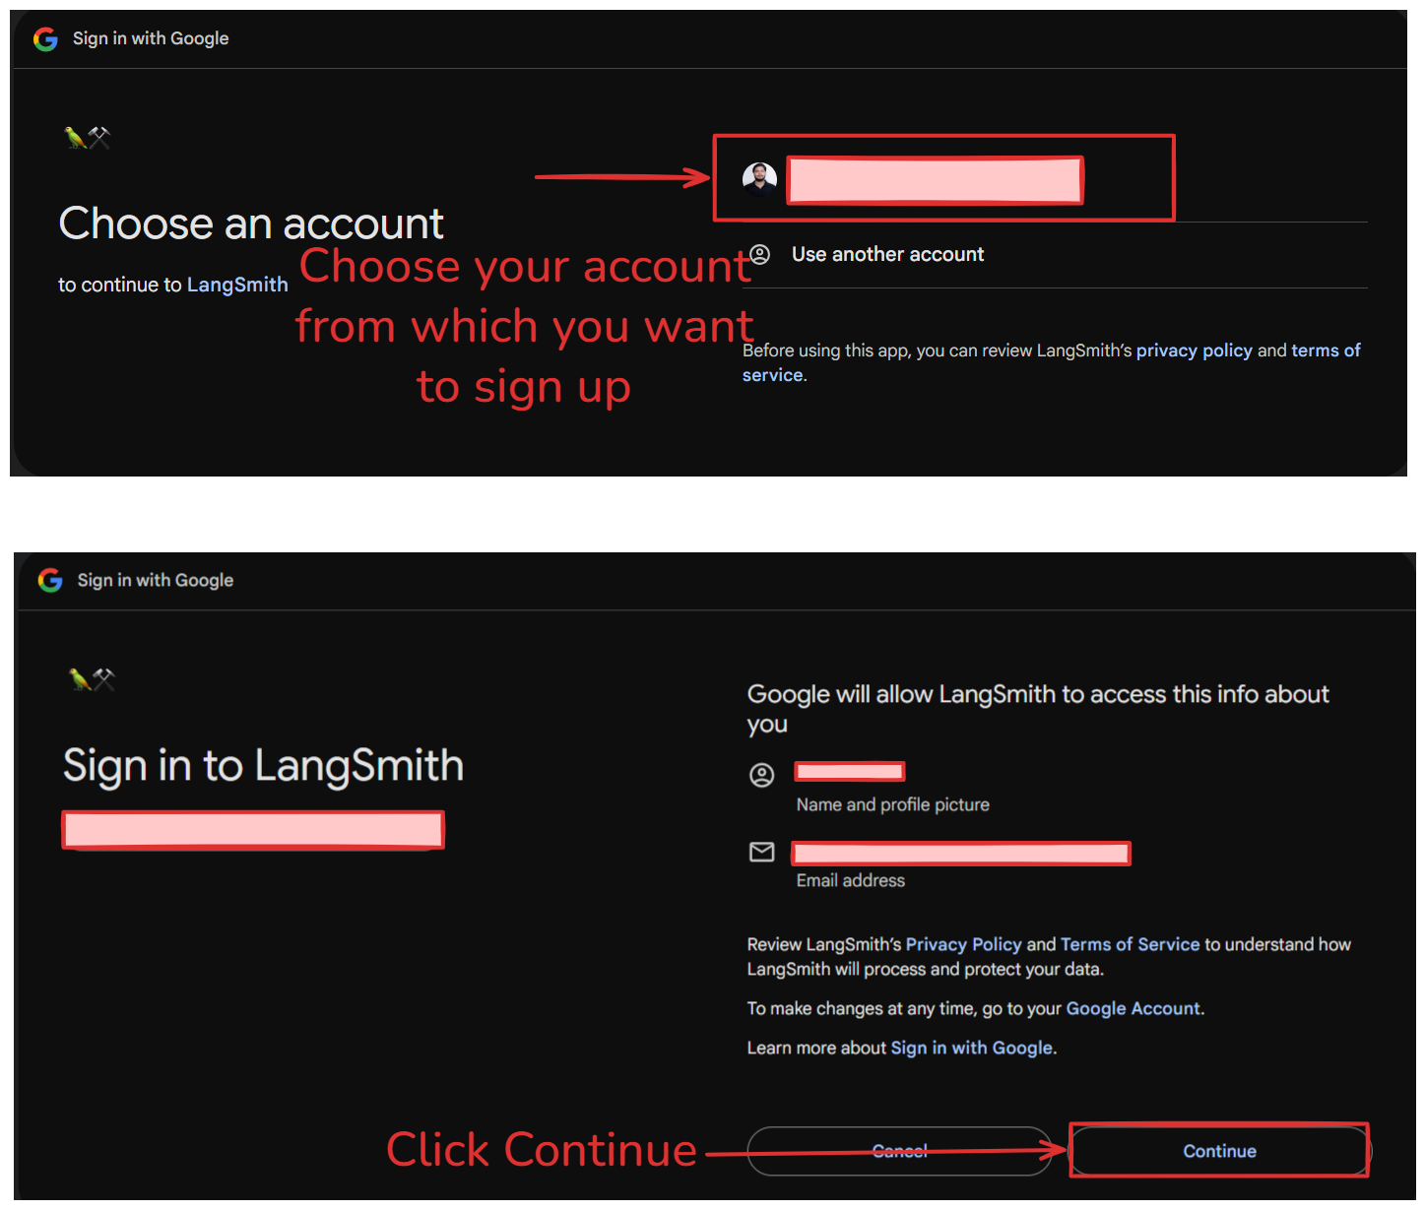
Figure 2.1 - Google Sign-In via LangSmith

2.1 Click the Google Sign-Up Option on LangSmith
On the Create an Account screen (from Step 1), under "Sign up with", click the Google (G) icon. This will open a Google authentication page.
ℹ️ Note
If nothing happens, your browser may be blocking popups - allow popups for smith.langchain.com and try again.
2.2 Choose the Google Account You Want to Use
You will land on the "Choose an account" screen. Click the Google account you want to use for LangSmith.
If the right account is not visible, click Use another account and sign in with the correct email + password (and complete any 2-factor authentication if prompted).
2.3 Review the Google Permission / Consent Screen
After selecting your account, Google will show a consent screen: "Google will allow LangSmith to access this info about you". Typically shown items include your name, profile picture, and email address.
This is standard OAuth sign-in - LangSmith needs basic profile info to create and identify your user. Quickly review the permissions being requested.
2.4 Click "Continue"
Click the Continue button (bottom-right). You should be redirected back to LangSmith automatically.
2.5 Verify You're Signed In
Once redirected back, you should now be inside LangSmith (or it may ask for a quick first-time setup like workspace/org name). If you still see the signup screen, refresh once.

⚠️ Common Issues & Fixes
Popup blocked: Allow popups for smith.langchain.com → retry Step 2.1
Wrong Google account signed in: Go back → choose Use another account
Stuck after Continue: Refresh page → try again in an incognito window
Org-managed Google account restrictions: Try a personal Google account or check with your IT admin
STEP 3 Complete (or Skip) LangSmith Onboarding Screens
Goal: Get past the onboarding questions and reach the main LangSmith dashboard/workspace.
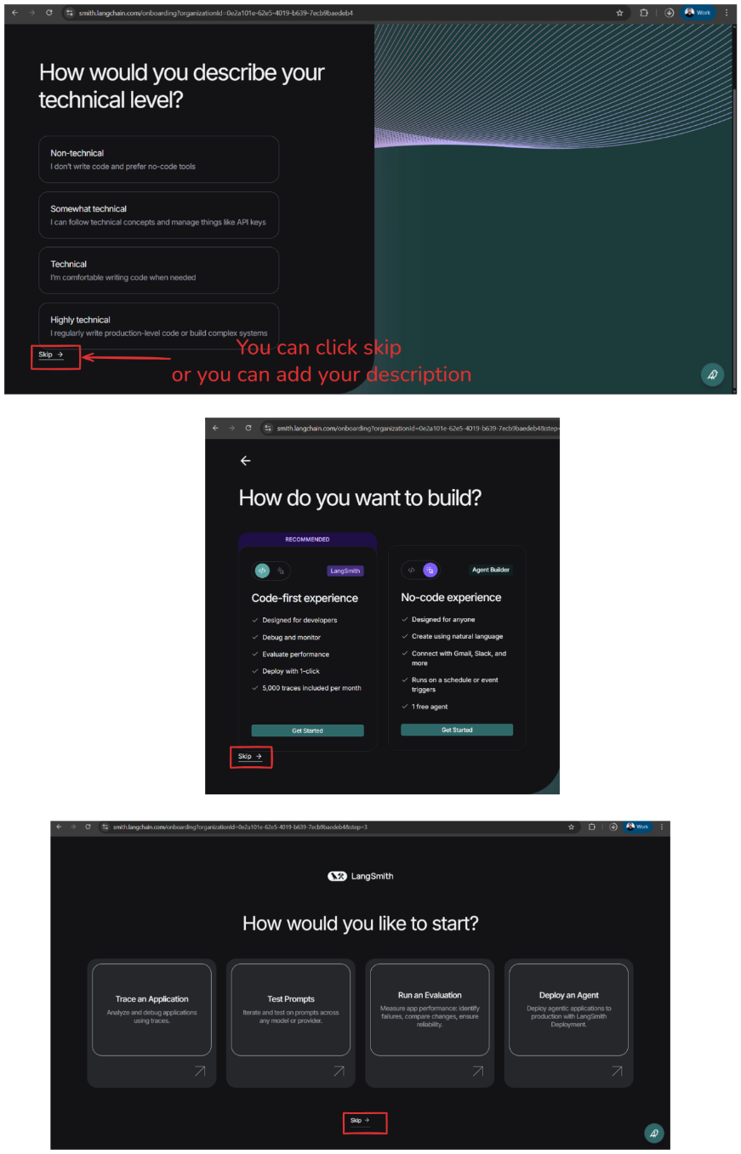
Figure 3.1 - LangSmith Onboarding Screens

3.1 Onboarding Screen 1: Select Your Technical Level (or Skip)
When you sign in for the first time, LangSmith may ask: "How would you describe your technical level?" You'll typically see: Non-technical, Somewhat technical, Technical, or Highly technical.
Option A (Recommended for most learners): Select one option
Click the option that best matches you. This helps LangSmith tailor tips and defaults, but it doesn't affect core product access.
Option B: Skip this step
If you don't want to answer, click Skip → (bottom-left). You can still use LangSmith fully.
✅ Outcome
You move to the next onboarding screen.

3.2 Onboarding Screen 2: Choose How You Want to Build (or Skip)
Next, LangSmith may ask: "How do you want to build?" You may see two paths:
- Code-first experience (recommended) - geared for developers who want to instrument code, trace, debug, and evaluate.
- No-code experience - geared for creating workflows/agents without writing code.
Option A (Recommended for your setup): Choose "Code-first experience"
Click Get Started under Code-first experience. This aligns best with typical LangSmith usage (tracing, evaluation, dataset runs, etc.).
Option B: Skip
Click Skip → (bottom-left) if you want to set this later.
✅ Outcome
You move to the next onboarding screen.

3.3 Onboarding Screen 3: Choose What You'd Like to Start With (or Skip)
You may then see: "How would you like to start?" Common tiles include:
- Trace an Application (instrument + debug traces)
- Test Prompts (prompt playground / iterations)
- Run an Evaluation (evaluate model outputs vs dataset)
- Deploy an Agent (agent deployments, if enabled)
Option A (Recommended for setup docs): Skip
Click Skip → at the bottom. We'll first finish setup (API key + env vars), then come back to these features.
Option B: Choose a starting tile (optional)
If you know what you want, click a tile. LangSmith will open that feature area directly.
✅ Outcome
You reach the main LangSmith workspace/dashboard.
3.4 Verification Check (You're Done with Onboarding)
You should now see one of these:
- A LangSmith dashboard (projects/workspaces/traces/evals navigation)
- Or a workspace landing screen prompting you to create/select a project
STEP 4 Understand the LangSmith Dashboard (Home Screen)
Goal: Get familiar with the LangSmith UI to navigate projects, traces, evaluations, and settings.
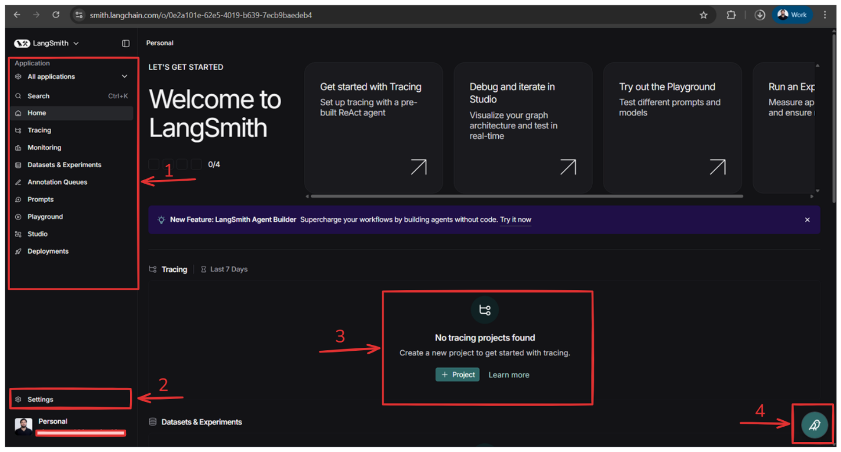
Figure 4.1 - LangSmith Main Dashboard

4.1 Confirm You're on the Correct Screen
After completing onboarding, you should land on the Home page of LangSmith, which typically shows:
- A left navigation panel (sidebar)
- A central "Welcome to LangSmith" area
- Quick-start cards (Tracing / Studio / Playground / Experiments)
- A section indicating whether any projects exist (e.g., "No tracing projects found")
4.2 Left Sidebar (Navigation Menu) - Label 1
This left panel is your primary navigation. Here's what each major section typically does:
4.2.1 Application Selector (top-left)
"All applications" dropdown lets you switch between your personal workspace and team/org workspaces (if you're added to any). Use this if you have multiple orgs or projects under different workspaces.
4.2.2 Search (Ctrl + K)
The Search option helps you quickly find projects, datasets, runs/experiments, and other entities depending on what exists in your workspace.
4.2.3 Home
Returns you to the dashboard overview page (this screen).
4.2.4 Tracing
This is where you see execution traces from your app/agent. Use it to debug tool calls, prompt inputs/outputs, latency bottlenecks, failures and retries.
4.2.5 Monitoring
This is for production-style observability. You'll typically use it to track health over time (errors, latency), monitor usage trends, and spot regressions.
4.2.6 Datasets & Experiments
Used when you want to evaluate prompts/models systematically. Typical actions: create datasets (inputs + expected outputs), run experiments/evaluations, compare model versions or prompt variants.
4.2.7 Annotation Queues
Useful when humans need to label or review outputs. Common for human-in-the-loop evaluation and quality review workflows.
4.2.8 Prompts
A central place to store, manage, and version prompts. Useful when multiple people collaborate on prompts or you want version history.
4.2.9 Playground
Quick testing area to experiment with prompts and model responses. Good for fast iteration before shipping prompts to code.
4.2.10 Studio
A more structured space for debugging and iterating (often connected to traces/graphs). Useful for inspecting complex flows and refining agent behavior.
4.2.11 Deployments
If enabled in your account/org, this is where you manage deployed agents/apps. Not every user/org will use this immediately.
4.3 Settings (Label 2): Why This Is Important
At the bottom-left, you'll find Settings. You'll use Settings for critical setup tasks like:
- Creating / managing API keys
- Workspace/org settings
- User profile settings
- Possibly billing/plan (depending on permissions)

✅ Important
In this setup guide, Settings is a key navigation point because later steps require generating an API key to connect your code (LangChain/LangGraph/etc.) to LangSmith.
4.4 "No Tracing Projects Found" + Create Project (Label 3)
In the main panel, LangSmith is telling you: "No tracing projects found. Create a new project to get started with tracing."
LangSmith organizes traces under Projects. Until you create a project, your app won't have a place to log traces. Click + Project to create your first tracing project.
4.5 Help / Assistant Button (Label 4)
Bottom-right shows a chat/help icon. This opens LangSmith help/support assistant. Useful if you get stuck, need quick documentation links, or want to search help articles.
STEP 5 Open Settings → API Keys and Create a New API Key
Goal: Navigate from the LangSmith dashboard to the API Keys page and generate an API key.
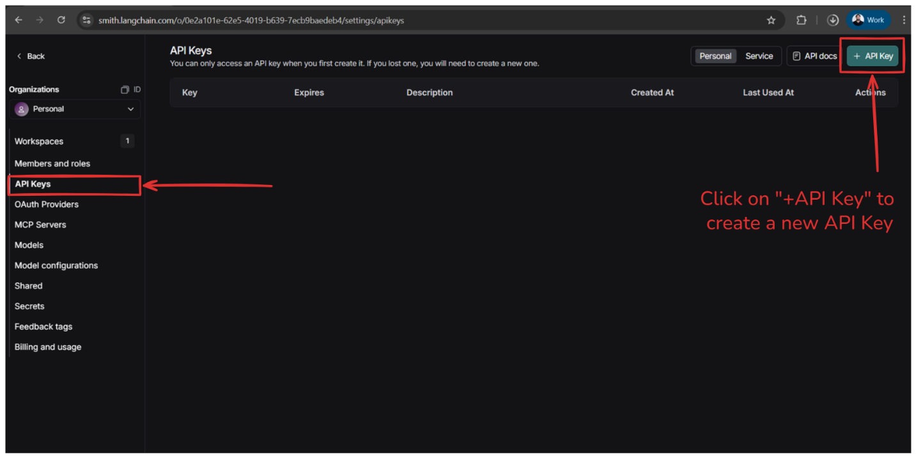
Figure 5.1 - Settings → API Keys Navigation

5.1 Navigate to Settings from the Dashboard
- Make sure you are on the LangSmith dashboard/home screen (Step 4).
- Look at the bottom-left of the left sidebar.
- Click Settings.

✅ What you should see after clicking Settings
A settings panel opens with options like Organizations, Workspaces, Members and roles, and API Keys in the left menu.

ℹ️ Note
If you don't see "Settings", scroll down in the left sidebar - on smaller screens it may be below the fold.
5.2 Open the API Keys Page
- In the Settings left menu, click API Keys.

✅ Verification
At the top of the main screen you should see the heading "API Keys". You may see an empty table (if you haven't created keys yet) with columns like Key, Expires, Description, Created At, Last Used At.
5.3 Confirm You're in the Right Organization (Left Panel)
On the left side, under Organizations, you'll typically see Personal (selected). For most learners, Personal is correct.
ℹ️ Note
If you're part of a team/org, confirm you're in the right org before creating the key. API keys are created under the selected org/workspace context.
5.4 Create a New API Key
- On the top-right of the API Keys page, click + API Key.

✅ After clicking
LangSmith will open a key creation flow where you can add a name/description, set expiry (if available), and generate the key.

⚠️ Important
LangSmith typically shows the full API key only once at creation time. You must copy it immediately and store it safely.
5.5 Best Practices for Naming + Storing Your Key
Recommended Naming
Use a name that tells you where you'll use it, e.g.:
- local-dev-laptop
- n8n-workflow
- agentic-course-smoketest
Safe Storage (What To Do)
Copy the API key and save it in a secure place:
- Password manager (preferred)
- A secure secrets manager
- Your environment variables (next step)
🚫 Avoid These Mistakes
❌ Don't paste the key into Google Docs/Notion publicly
❌ Don't commit it into GitHub
❌ Don't hardcode it inside Python/JS files

STEP 6 Create a LangSmith API Key (Description → Expiry → Generate)
Goal: Generate your LangSmith API key to connect your local code / notebook / app to LangSmith.
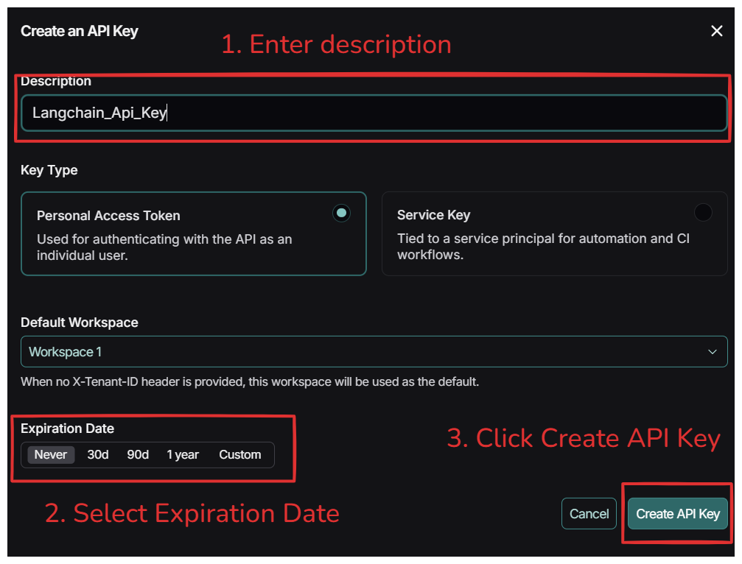
Figure 6.1 - Create API Key Modal

6.1 Open the "Create an API Key" Pop-up
After you click Settings → API Keys → + API Key (Step 5), a pop-up/modal opens titled "Create an API Key". This modal is where you define the key label (description), key type, default workspace, and expiry date.
6.2 Enter a Clear Description (Label 1)
- Click inside the Description field.
- Type a meaningful name so you can recognize this key later.

💡 Recommended Naming Examples
LangSmith - Local Dev
LangSmith - Agentic Course
LangSmith - Tracing

If you create multiple keys later, descriptions help you identify which key is used where.
6.3 Choose the Key Type (Important Decision)
Option A: Personal Access Token (most learners should use this)
This is used for authenticating as you (an individual user). Best for local development, notebooks, learning setups, and personal projects.
✅ Recommended
Personal Access Token is recommended for this setup guide.

Option B: Service Key (for automation/CI)
This is tied to a service principal. Best for CI/CD pipelines, production automation, and server-to-server usage. If you're unsure, choose Personal Access Token.
6.4 Confirm the Default Workspace
- Look at the Default Workspace dropdown (e.g., "Workspace 1").
- Keep the default selection unless you have a specific workspace you want traces to go into.
If your code doesn't explicitly specify a workspace/tenant header, LangSmith will use this workspace by default.
6.5 Select an Expiration Date (Label 2)
In Expiration Date, you can choose: Never, 30d, 90d, 1 year, or Custom.
💡 Recommended Choices
For learners / quick setup: 90d or 1 year
For long-term personal usage: 1 year (or Never if your org policy allows it)
For security best practice: avoid "Never" unless you're confident about safe storage
Tip: Shorter expiry = more secure, but you'll need to rotate the key later.
6.6 Click "Create API Key" (Label 3)
- Review your selections quickly (Description + Key Type + Expiry).
- Click Create API Key.

✅ What happens next
LangSmith generates the API key and shows it to you (usually in the next modal/screen). You will typically be able to copy it only once.

⚠️ Important
If you close the window without copying it, you usually cannot retrieve the full key again - you must generate a new key.
6.7 What To Do Immediately After the Key Is Shown
Once LangSmith displays the key:
- Copy the key
- Store it securely (see Step 7 for detailed instructions)

STEP 7 Copy and Securely Save Your New API Key
Goal: Copy the newly generated LangSmith API key and store it safely for use in your local environment.
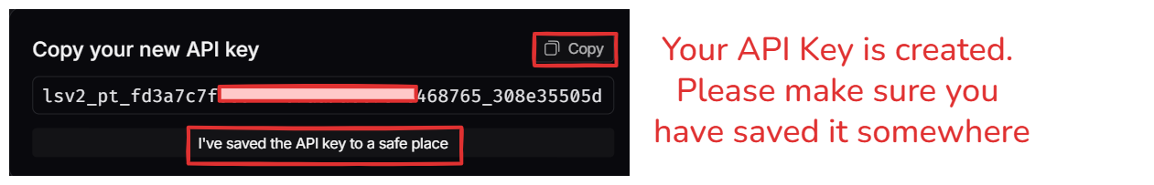
Figure 7.1 - Copy Your New API Key Screen

7.1 Understand This Screen (Why It Matters)
After you click Create API Key (Step 6), LangSmith shows a screen titled "Copy your new API key".
⚠️ Critical Note
In most tools (including LangSmith), the full API key is shown only once. If you close this screen without saving it, you usually cannot view it again and will need to create a new key.
7.2 Copy the API Key
- Locate the API key field (a long string starting with something like lsv2_...).
- Click the Copy button (top-right of the key field).

✅ Verification
Your clipboard should now contain the API key. Some browsers may show a small "Copied" confirmation.

ℹ️ Manual Copy
If Copy doesn't work, click inside the key field, press Ctrl+A (or Cmd+A), then Ctrl+C (or Cmd+C) to copy manually.
7.3 Save the API Key in a Safe Place (Do This Immediately)
Choose one secure option:
Option A (Recommended): Password Manager / Secrets Vault
Save it in a password manager (1Password, Bitwarden, LastPass) or a secrets vault.
Option B: Local Secure Note (Temporary)
Save it in a private, local note that is not shared (and delete it after setting env vars).
Option C: Environment Variables (What We'll Do Next)
Add it to your system environment variables so your code can read it securely. This is the most common workflow for developers.

🚫 Avoid
Google Docs / Notion pages that can be shared
Slack/WhatsApp messages
Adding it inside code files
Committing it to GitHub
7.4 Confirm You Saved It (Checkbox)
- After saving the key, tick the checkbox: "I've saved the API key to a safe place"
This ensures you don't accidentally proceed without storing the key.

STEP 8 Verify Your API Key Was Created Successfully
Goal: Confirm your key is created, understand what you can/can't do on this page, and know what to do next.
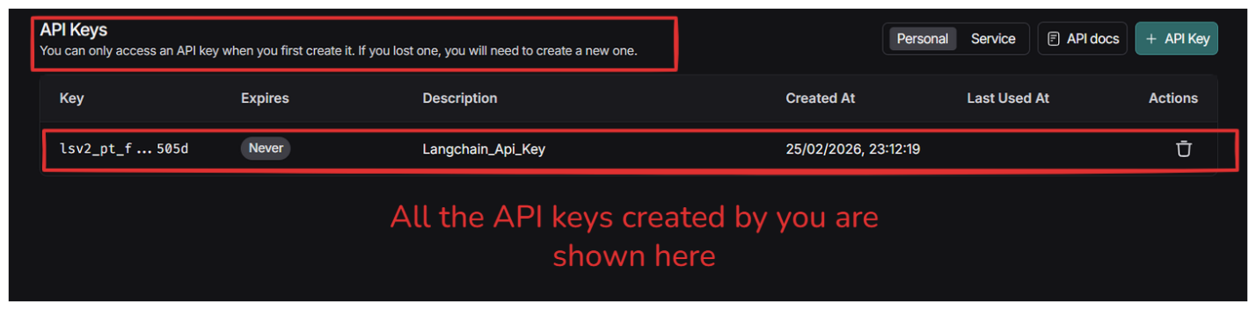
Figure 8.1 - API Keys List Page

8.1 Confirm You're Back on the API Keys Page
After you copy and save the key (Step 7), LangSmith returns you to the API Keys page where all keys are listed.
At the top, you'll see a note like: "You can only access an API key when you first create it. If you lost one, you will need to create a new one."
✅ Meaning
LangSmith will not show the full key again after creation.
8.2 Know How to Delete/Revoke a Key (If Required)
On the far-right of each key row, you'll see a trash/delete icon. Use this when:
- You think the key is compromised
- You no longer need a key
- You accidentally created multiple keys

⚠️ Warning
Deleting a key immediately revokes access for any app/workflow using it.

OpenAI API Key – Allowed Models & Troubleshooting
Allowed Models
Your Interview Kickstart OpenAI API key provides access to the following models. Please use only these models for the course projects:
- gpt-4o-mini
- gpt-4o
- tts-1
- whisper-1
- omni-moderation-latest
- text-embedding-3-small
- text-embedding-3-large
- text-embedding-ada-002
Please test your project before the class
We recommend running the project once before the live class by following the provided instructions. This will help you identify and resolve any setup or configuration issues in advance.
If you face a rate limit or quota error during the class:
When multiple learners run the same models simultaneously, some models may temporarily experience high usage. You may see errors such as “Rate limit exceeded” or “Quota exceeded.”
If you encounter these errors:
- Wait for 5–10 minutes and try running the project again.
- Your API key has sufficient credits for the course projects, so please do not worry about the error immediately.
- If the issue continues, try running the project again after the class.
If your API key appears to be invalid or is not working:
You can verify your API key using the OpenAI API Key Tester:
OpenAI API Key Tester: https://trevorfox.com/api-key-tester/openai/
If the key is still not working after verification, please contact the Operations team for support.

